Implementation of COBIT5 in a Higher Educational Institution in Australia

Author:

Kalyan Pandey
Crown Institute of Higher Education
Sydney, Australia
cihe21214@student.cihe.edu.au
kalyanpandey6463@gmail.com

Abstract

Based on the COBIT5 (Control Objectives for Information and Related Technology 5) framework and its implementation in the higher educational institution in Australia, this report presents the importance of IT Governance, the governance, risk and compliance framework and the methodology for COBIT5 to be properly implemented in this sector. This paper argues how COBIT5 can positively impact more than 1,100 institutions in Australia comprising more than 22,000 courses touching 1.3 million current students. The effect of COVID-19 on the higher education sector has also been taken into consideration in this paper and COBIT5’s immediate relief to it. The methodology to implement COBIT5 and the positive outcome of implementing it in higher educational institutions in the context of Australia can be discovered in this report in addition to the regulatory compliance, risk management system, and achievement of business needs and goals.

Keywords—Governance, Risk, and Compliance (GRC) Framework, COBIT 5, ISACA, Higher Educational Institute, Australia, COVID-19, Integration of COBIT 5, IT Governance, Risk Management.

Table of Contents
Abstract 2
1. Introduction 4
2. Literature Review 4
3. COBIT5 Framework Implementation 6
3.1. Step 1 – Establish business drivers relevant to the IT processes 7
3.2. Step 2 – Set up the IT processes in the enterprise 8
3.3. Step 3 – Perform a prior selection of target processes based on the above selection 9
3.4. Step – 4 Confirm the prior selection of target processes with the project sponsor and key stakeholders 9
3.5. Step – 5 Finalize the list of processes 10
3.6. Step 6 – Document the scoping methodology in the IT strategy document 11
4. Conclusion 12
5. References 13

Introduction

Information Technology Governance Framework tends to form a stable connection between business needs and goals, considering profitability for the organization so effective IT governance is an essential crucial factor for an organization of any size. Due to the many advantages an organization can gain through IT GRC, its demand has increased in many sectors such as the healthcare, education system, transportation, fashion, and food industries. This report will depict the IT GRC framework, COBIT5, implementation in the higher education system such as bachelor, master's and doctoral degrees in Australia.

In recent years, the course of learning in institutions and universities has quite changed due to external factors such as COVID-19 precautions, as well as the promotion of online semester-based learning through the institutes and e-learning through available online platforms. These couple of years has changed the traditional way of teaching and learning process for the lecturers and the students, also taking into consideration the online examinations (Ingrid H. 2020). It can be observed that the whole education process has very much relied upon IT and the internet which demands the proper use of IT GRC in this sector. If an institution now lacks effective IT governance, then corresponding consequences such as reduced performance of IT resources, increment in operational expenses, sceptical data quality, and other security concerns will be soon observed. So, this report intends to point out the importance of COBIT5 implementation in higher educational institutions in Australia and the following steps to properly implement and put it in the required position.

Literature Review

The literature review is the foundation for all forms of scientific study (Webster and Watson 2002). Additionally, a knowledge base of theories and concepts related to research in any field may be built during the course of a literature review. In this study, the use of IT governance and implementation of the COBIT 5 framework in higher education is reviewed in the literature.

Information Technology Governance:
An organization's goals can be directed and controlled by using an IT governance framework of relationships and processes, which adds value while managing risk by modifying the company's IT and business processes (Weill & Ross, 2004). The development of IT governance as a link between business scope and IT has reduced the gap between the actual use of technology and expectations. Implementing structures, processes, and relational mechanisms requires efficient IT governance to manage this heterogeneous collection of technology. Each of these mechanisms serves a purpose, and when used, they should positively affect the organization. Furthermore, according to Grama (2015), efficient IT governance enables an institution to use IT resources in the best possible ways to achieve its objectives.

COBIT 5 Framework:
COBIT 5 is an IT governance framework that assists organizations in generating optimal value from IT by balancing benefits realization, risk management, and resource utilization. COBIT was developed in 1992 by the Information Systems Audit and Control Association (ISACA). The release of COBIT 5 in 2012 made it possible for information and related technology to be governed and managed holistically for the entire organization, taking into account all business and functional areas of responsibility and taking into account the IT-related interests of both internal and external stakeholders.
The COBIT framework is focused on assisting in meeting the needs of the organization to present the information. It helps to manage and control the IT resources by using a structured set of procedures to deliver information technology services that deliver the needed information for the organization (Cecil. 2017). Figure 1 represents the principle of the COBIT5 framework.

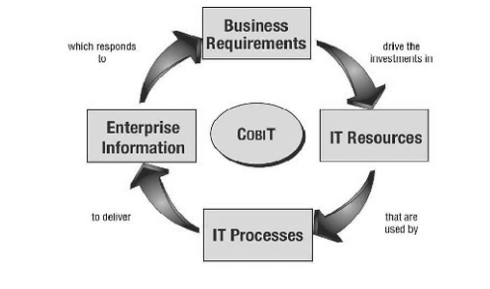
Fig 1: COBIT5 Framework Principle
Source: COBIT® 5, figure 10. © 2012 ISACA® All rights reserved.

Implementation of COBIT 5 in Higher education in Australia based on IT Governance:

Although COBIT 5 is not mandatory, it suggests that organisations such as Higher Education use governance and management procedures to cover important areas. If the essential governance and management goals are met, an organization is free to arrange its processes however it sees proper.
Five governance processes are included in COBIT 5, and evaluate, direct, and monitor (EDM) techniques are established for each process. Additionally, it has four management domains that correspond to the responsibilities of the plan, build, run, and monitor (PBRM) and offers comprehensive IT coverage. The domain names, which include extra verbs to characterize them, were chosen by these primary area designations: Align, Plan and Organize (APO), Build, Acquire and Implement (BAI), Deliver, Service and Support (DSS), Monitor, Evaluate and Assess (MEA).
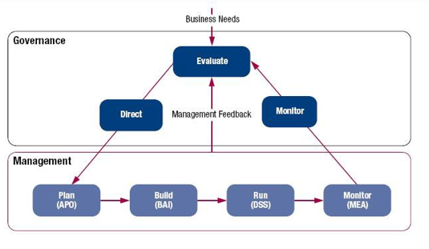
Fig 2: Relation between Governance, Risk and Management
Source: COBIT® 5, figure 07. © 2012 ISACA® All rights reserved.
The COBIT 5 highlights the benefits of IT for operations that increase cost and time efficiency in both higher education and business. Migration from a manual data processing system to a systematic academic system has undergone significant modifications, particularly in the delivery of e-learning systems. Additionally, it is essential to set strategic goals and choose wisely when it comes to investing in IT if the educational institutions in Australia are to achieve their goals and increase their effectiveness and competitiveness. In Australian higher education, COBIT 5 aims to achieve excellence in instruction, learning, research, and development. Some of the goals of implementation of COBIT 5 in higher education are listed below:

- To support organizational decisions and enhance and safeguard high-quality data.
- Existing issues such as delayed internet connectivity within the college region, data integrity, and IT vulnerabilities should be properly evaluated and rectified to eliminate IT governance problems. Data and privacy security should be enjoyed by students and employees.
- To ensure that IT-related operations, such as the current learning management system, academic and human resource management, etc., are exceptionally competent and in line with the institute's goal and purpose.
- To keep an eye on and evaluate the maintenance program's handling of student data.
- Keep track of and assess the organizational efficacy of present resources so that they can be acknowledged and improved later. This includes reporting to the director's dashboard.

COBIT5 Framework Implementation

COBIT framework is the platform widely used for IT governance where the organisation benefits from its capability to securely manage and operate the information and data. So, adopting COBIT can effectively bridge the gap between IT businesses like educational institutions that can handle the institution’s information.

The structure of the higher education system is a massive organisation with many pupils, stakeholders, and employees with their data functioning to provide education and cover a variety of subjects and the implementation of COBIT is one of the most reliant tools to optimise the value of the Higher Educational Institution of Australia and meet its objective. COBIT framework tracks the progress and achievement of the stakeholders by identifying and supporting tackling the disruptions or risks that may arise (Zia-ur-Rehman, 2016).
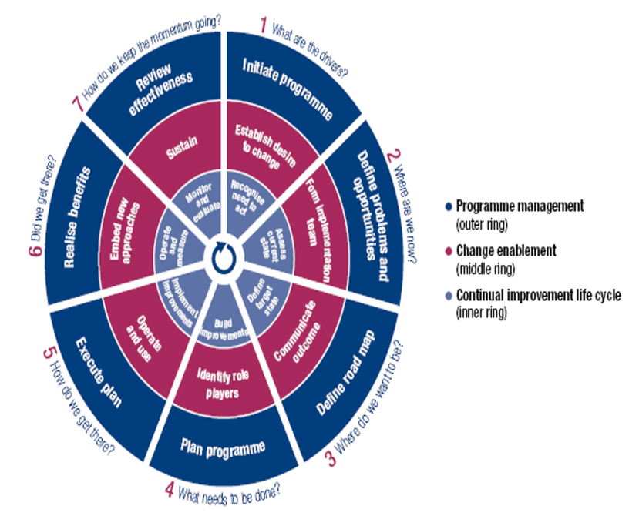

Fig 3: Implementation life cycle of COBIT5
Source: COBIT® 5, figure 17. © 2012 ISACA® All rights reserved.

Step 1 – Establish business drivers relevant to the IT processes

The IT processes in the educational institution correspond with the demands of the institution irrespective of IT demands or needs. The principal and school board are the main stakeholder groups in a higher education institution.

- Meeting stakeholder requirements: people have the final say in all issues about the organisation. The following is a list of some of the stakeholder specifications for adopting COBIT 5 in higher education:

• It is essential that IT-related efforts are time and money efficient. It is necessary to examine both the existing business processes and the overall IT efforts to ensure that they will generate the desired results.
• Verify that stakeholders are kept up to speed as necessary and that sufficient information on IT governance processes is supplied in compliance with regulations in effect at the time.

- Encompassing the entire enterprise

• Examines the need for IT governance and confirms that the institution's IT governance policies and procedures are consistent with its aims.

The organisation's objectives and operations should be considered when designing the academic data processing system. Proper risk management is essential to reducing budget costs, time-consuming design errors, and product failures.

- Consisting of the entire business

• Considers if IT governance is necessary and verifies that the institution's IT governance rules and practices are in line with its objectives.

When creating the academic data processing system, the goals and procedures of the organisation should be considered. Reduced budget expenditures, time-consuming design flaws, and product failures can all be prevented with proper risk management.

- Facilitating a comprehensive approach –

• Maintain a capable IT governance structure by carrying out routine system audits. All of it is done to ensure that the present learning management system's components—including the management of academic and administrative resources and other IT-related elements—align with the university's objectives and purposes.

- Distinguish management from governance –

• Assesses the institute's need for IT governance and regulates IT governance policies and procedures to the institution's mission and objectives.
• Use IT governance to identify and reduce potential internal and external risks.

Step 2 – Set up the IT processes in the enterprise

IT processes using COBIT

- Standard selection as COBIT:
COBIT makes sure that both the processes and the duties related to all facets of IT are addressed. Additionally, COBIT 5 offers the framework required to make sure that alignment exists between stakeholder requirements, enterprise goals, and IT-related goals, as well as between all enablers (Horvath, 2022).

- The Initial Version
The initial functional organisation is directly derived from COBIT 5 and is made up of the following functional components:

- The executive committee of the Board of Directors (BoD)
- Steering committee (reporting to the chief executive officer [CEO])
- CEO
- Information officer in charge (CIO)
- EDM domain: evaluate, direct, and monitor
- APO domain: Align, Plan, and Organize
- The domain of Build, Acquiring, and Implement
- The domain of Deliver, Service, and Support
- The domain of Monitoring, Evaluation, and Assessment
- The MEA Section's design
Large and medium-sized IT settings ought to include an IT assurance division that makes sure IT governance is carried out within the IT setup. It collaborates with the institution's internal audit when preparing and carrying out technological audits. To plan, implement, and track compliance with laws, codes, standards, and best practices, it will work with the corporate compliance department for the educational institution.

- Create the job descriptions.
Designing the corresponding job descriptions is important after creating the organisational structure. The tasks and associated metrics provided by COBIT5, and the activities mentioned in SFIA V6 can be used to construct job descriptions.

Step 3 – Perform a prior selection of target processes based on the above selection

Before finalising the job descriptions, the following must be guaranteed:

- The COBIT 5 must be assigned to all activities in the institution.
- In COBIT 5, all pertinent metrics will be allocated.
- Every skill described in SFIA V6 at every level of responsibility has a corresponding assignment.
- Any tasks, associated metrics, and abilities (at any level of responsibility) that have not been assigned should be recorded, along with a justification for why they have not been.

- Update IT procedures
The IT procedures and the job descriptions ought to be coordinated. As a result, it's essential to examine all IT processes and reassign duties to ensure that they correspond with the updated job descriptions.
The best way to establish and maintain an IT organisation is with the right tools. Included among the necessary skills are:
- Process management
- Enterprise architecture
- Risk management.
Numerous instruments for governance, risk management, and compliance (GRC) have been evaluated and examined from the standpoint of how they may be used in organisation design. A GRC tool that integrates risk management, corporate architecture, and strong process management capabilities is essential (Horvath, 2022). Additionally, it would be nice if those tools could enable maturity assessments.

Step – 4 Confirm the prior selection of target processes with the project sponsor and key stakeholders

- Define and examine the forces behind the change: existing issues such as delayed intranet connectivity within the college region, data integrity and IT vulnerabilities should be carefully identified and resolved to eliminate IT governance faults. Data and privacy security should be enjoyed by students and employees.

- Choosing where we must go: enhance and maintain high-quality data to support organizational decisions. We can keep our IT governance system effective by performing routine system evaluations.

- Determine what needs to be improved: to keep up with contemporary technological breakthroughs, monitor and analyse the maintenance program and the student data processing procedure, and use technology to automate and streamline the human process of managing student data.

- Create strategies and envision how to reach the EDM domain used by IT governance in universities: By creating and deciding on realistic targets that are informed by prioritization and are also evaluated for performance, EDM ensures that stakeholder requirements are assessed.
For every COBIT 5 process, action plans were to be recognized along with five supporting questions and every question relating to COBIT Process Assessment Model (Fig 4).

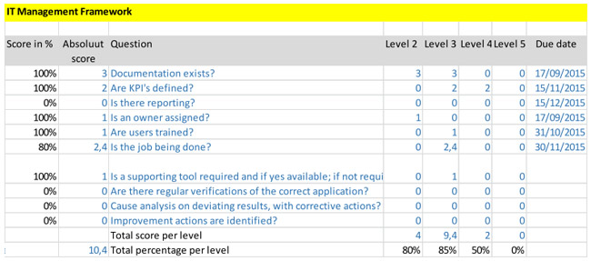

Fig 4: Example status for one process
Source: Greet Volders, figure 9. © 2016 ISACA® All rights reserved.

Step – 5 Finalize the list of processes

- Evaluate results to determine where we stand: Analyzing and identifying what company resources are now required based on KPIs and linking them to resource development. The KPI design is also used to evaluate educational policies and goals.

- Ensure risk optimization: Determine that the possible risks can be mitigated. To reduce IT governance problems, present threats such as disrupted intranet access, data integrity, and IT vulnerabilities should be carefully acknowledged.

- Ensure resource optimization: to be acknowledged and altered later organizational success needs to be tracked and evaluated, including reporting to the director’s dashboard ensuring that those resource needs can change to accommodate new planning and the school’s intention to install an e-learning system.

- Make sure stakeholders are transparent: assure prompt dissemination of IT governance information to stakeholders and close attention to project management.

The final action list (Fig 5) of the processes from the above step is put into a single sheet for everyone to remain on the same page and understanding.

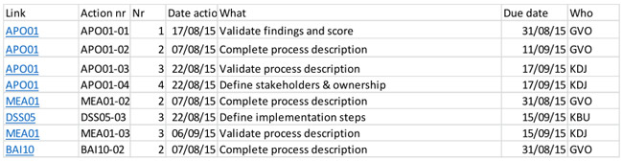
Fig 5: Final Action List
Source: Greet Volders, figure 10. © 2016 ISACA® All rights reserved.

Step 6 – Document the scoping methodology in the IT strategy document

A higher education institution has many stakeholders which could hurt the project due to a variety of viewpoints. Large companies, and higher education institutions, house hundreds of students and their data. It also covers a wide range of other subjects, which makes the project more complicated.

Further planning and follow-ups are recorded similarly with consideration of all the achievements and the detail of each process (Fig 6)
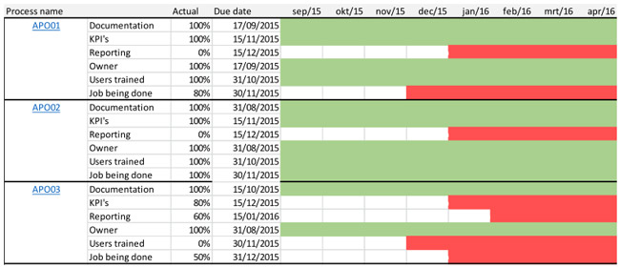

Fig 6: Process planning and follow up
Source: Greet Volders, figure 11. © 2016 ISACA® All rights reserved.

Finally, the result is put down in a process progress sheet to monitor the status of each process and the following progress (Fig: 7).

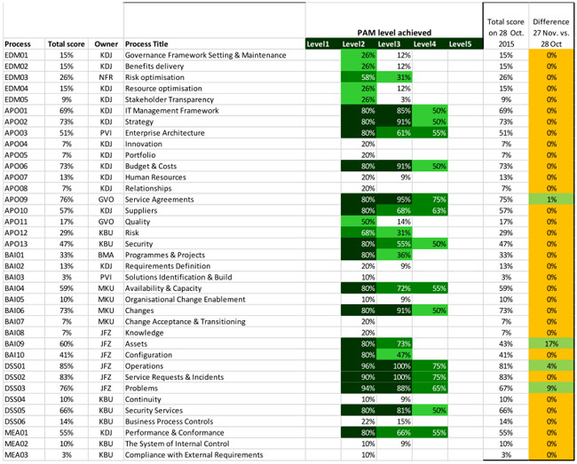

Fig 7: Process Progress Sheet
Source: Greet Volders, figure 12. © 2016 ISACA® All rights reserved.

Conclusion

Simply stated, COBIT 5 helps higher education institutions to create optimal value from IT by creating a balance between understanding the possible benefits, subsiding the risk levels and sustainable use of resources by acting as a guide or a valuable benchmark. COBIT 5 holistically believes in governance and management for the whole organization while considering all the potential IT-related interests of internal and external stakeholders. Knowledge of the significance of COBIT 5 gives educational institutions a crucial sense of the importance of its integration as well as the reduction and mitigation of any emerging risk (Cecil. 2017).

Implementation of COBIT 5 isn’t rocket science, instead, it is easily understandable through the various steps involved in it. The implementation steps introduced and discussed above give a brief theoretical idea of how it can be easily and practically implemented for effectiveness in performance, optimization of resources, accurate budget allocation and controlled expenditure for a good cause. Overall, the implementation of COBIT5 can leave nothing but a progressive influence on the higher educational institutions in Australia.

References

Bianchi, I., & Sousa, R. (2016). IT Governance mechanisms in higher education [eBook/online]. ELSEVIER. Available at: IT Governance Mechanisms in Higher Education (core.ac.uk)

Cecil., (2017). Practising Proper Governance with COBIT 5. [online] Available at: Practicing proper governance with Cobit 5 | by Cecil | Medium

Gunawan, W., Kalensun, E., Fajar, A., & Sfenrianto, S. (2018). Applying COBIT 5 in Higher Education. ResearchGate. [online] Available at: (PDF) Applying COBIT 5 in Higher Education (researchgate.net)

Horvath, I., (2022). What is COBIT? A Beginner’s Guide to COBIT Framework. [online] Invensis Learning Blog. Available at: What is COBIT? A Beginner's Guide to COBIT Framework (invensislearning.com)

Ingrid, H., (2020). Benefits Of COBIT 5 That Help Achieve Digital Transformation [online] Available at: Benefits Of Cobit 5: Everything You Should Know | Invensis Learning

Khther, R., & Othman, D. (2013). COBIT Framework As a Guideline Of Effective IT Governance In Higher Education: A Review [eBook/online] (pp. 21-29). International Journal of Information Technology Convergence and Services. Available at: Cobit Framework as a Guideline of Effective it Governance in Higher Education: A Review | Request PDF (researchgate.net)

Webster, J., & Watson, R. T. (2002). Analyzing the Past to Prepare for the Future: Writing a Literature Review. MIS Quarterly, 26(2), xiii–xxiii. [online] Available at: Analyzing the Past to Prepare for the Future: Writing a Literature Review on JSTOR

Weill, P., & Ross, J. (2004). IT Governance: How Top Performers Manage IT Decision Rights for Superior Results [eBook/online]. Harvard Business Press. Available at: Harvard Business Publishing Education

Zia-ur-Rehman, A., (2016). Using COBIT for IT Organizational Design. [online] ISACA. Available at: Using COBIT for IT Organizational Design (isaca.org)

