Bitcoin as a Decentralized Financial System: A Comprehensive Survey
Rijan Lama
Granville, Sydney
rijan153lama@gmail.com

Abstract
Bitcoin is the first decentralized cryptocurrency, introduced to enable peer-to-peer electronic transactions without reliance on central authorities. Since its inception, Bitcoin has evolved from a niche technological experiment into a globally recognized digital asset with significant economic, technical, and social implications. This survey provides a comprehensive overview of Bitcoin by examining its blockchain architecture, economic model, security mechanisms, adoption trends, and regulatory considerations. Prior research highlights Bitcoin’s role as both a technological innovation and an alternative monetary system (Nakamoto, 2008; Antonopoulos, 2017).
Keywords: Bitcoin · Blockchain · Cryptocurrency · Decentralization · Proof of Work · Digital Currency

Introduction
Bitcoin was introduced in 2008 to address limitations in traditional financial systems, particularly centralized control and trust dependencies (Nakamoto, 2008). By leveraging cryptographic techniques and distributed consensus, Bitcoin enables secure, transparent, and
censorship-resistant transactions. Subsequent studies have emphasized its growing relevance in finance, economics, and computer science research (Böhme et al., 2015).

Figure 1: Simplified Bitcoin Network Architecture
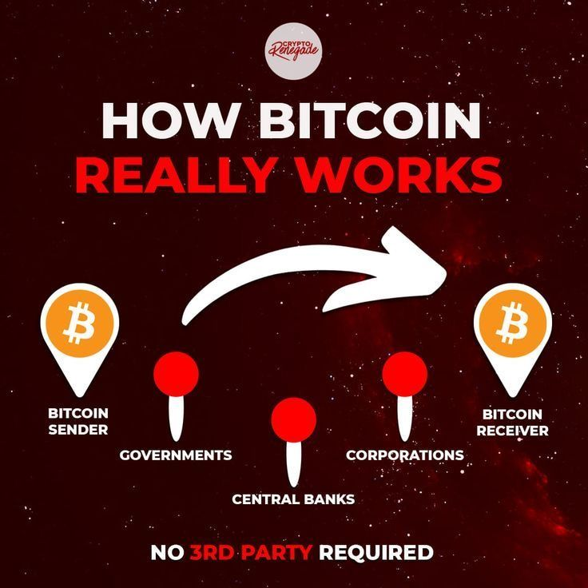

Survey Scope and Methodology
This survey adopts a systematic literature review methodology, drawing on peer-reviewed journal articles, foundational white papers, and institutional reports. Qualitative thematic analysis is combined with quantitative indicators such as network growth and adoption metrics to provide a balanced assessment of Bitcoin’s evolution (Narayanan et al., 2016).

Figure 2: Bitcoin Supply and Mining Process
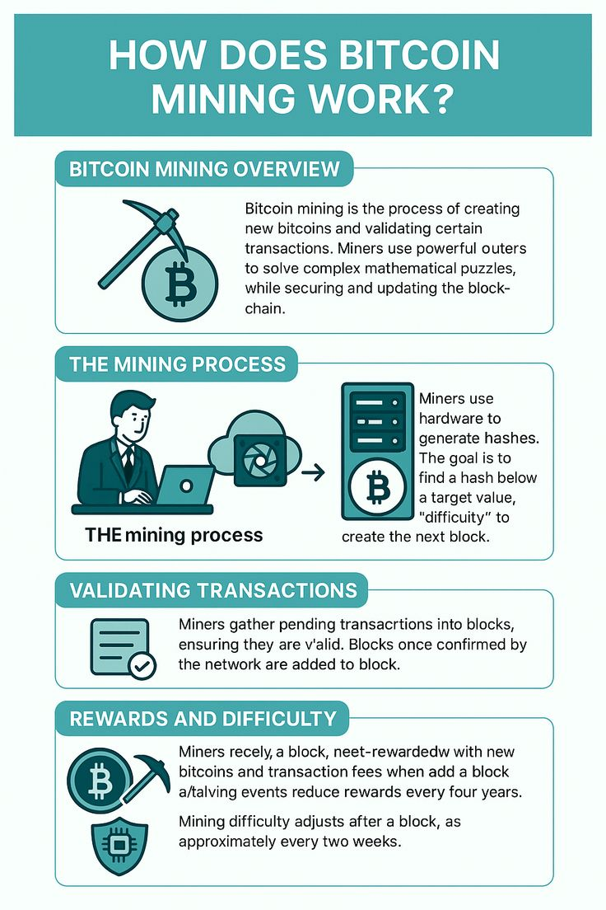

Conclusion
Bitcoin represents a transformative development in the global financial landscape. The survey highlights its strengths in decentralization, security, and transparency, while identifying persistent challenges related to scalability, regulation, and environmental sustainability. The anticipated insights reinforce Bitcoin’s dual role as both a technological innovation and an emerging financial system (Antonopoulos, 2017; Gervais et al., 2016).

References
Nakamoto, S. (2008). Bitcoin: A Peer-to-Peer Electronic Cash System.
Antonopoulos, A. M. (2017). Mastering Bitcoin. O’Reilly Media.
Narayanan, A., et al. (2016). Bitcoin and Cryptocurrency Technologies. Princeton University Press. Böhme, R., et al. (2015). Bitcoin: Economics, technology, and governance. Journal of Economic Perspectives.
Gervais, A., et al. (2016). On the security and performance of proof of work blockchains.

