Email Phishing Attacks Using the Social Engineering Toolkit (SET):
Mechanisms, Awareness, and Defensive Measures
Author: Sagar Khanal
Date: May 2026
AusJournal of Cybersecurity Research

Abstract
Email phishing remains one of the most prevalent and damaging cyber threats worldwide, accounting for over 90% of all data breaches. The Social Engineering Toolkit (SET), an open-source penetration testing framework, is widely used by both security researchers and malicious actors to simulate and execute email phishing campaigns. Despite growing awareness, users continue to fall victim due to increasingly sophisticated lure techniques and a persistent awareness–behaviour gap. This paper examines how SET facilitates email phishing attacks, analyses current behavioural trends, and proposes a structured survey instrument and targeted precautionary framework to reduce user susceptibility.
Keywords: Email Phishing · Social Engineering Toolkit · SET · Cybersecurity · Spear Phishing · User Awareness · Phishing Prevention

1 Introduction
Email phishing is a form of social engineering in which attackers impersonate trusted entities to deceive recipients into disclosing credentials, downloading malware, or transferring funds [3]. It is estimated that 3.4 billion phishing emails are sent every day globally, and phishing attacks cause financial losses exceeding $17,700 per minute [4]. The accessibility of automated attack tools has dramatically lowered the technical barrier for malicious actors, making phishing a widespread threat to individuals and organisations alike.
The Social Engineering Toolkit (SET), developed by TrustedSec and widely distributed through Kali Linux, provides a modular framework for constructing phishing campaigns, credential harvesting pages, and email mass-mailers [2]. Although SET was designed for authorised penetration testing and security awareness training, its capabilities are frequently misused by threat actors to conduct real-world attacks. Understanding SET's mechanisms equips cybersecurity professionals and educators to better prepare users and organisations against its misuse.
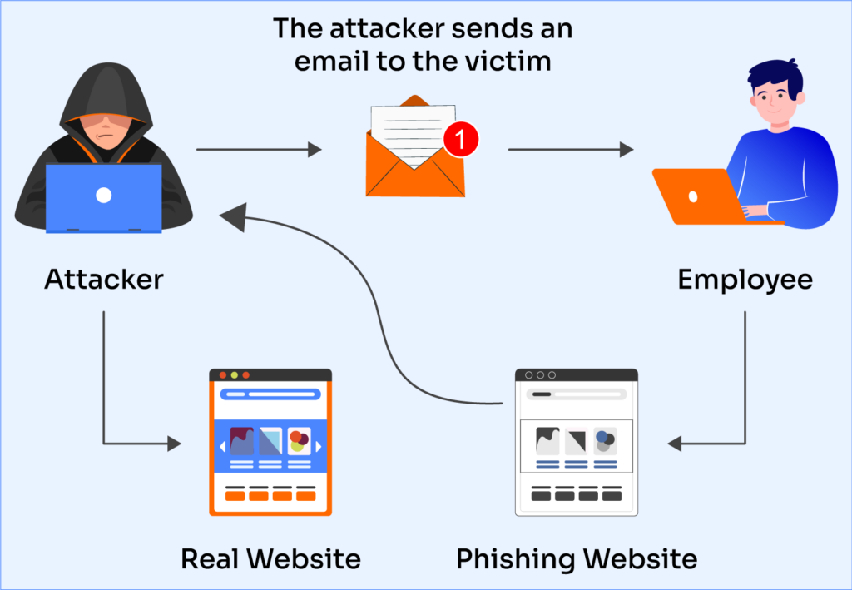
A 2025 IBM Security report noted that phishing was involved in 36% of all data breaches, and that the average cost of a breach initiated by phishing reached $4.88 million USD [5]. Despite this, studies show that 97% of users are unable to identify a sophisticated phishing email [6]. This research contributes a survey instrument, threat analysis, and a defensive framework grounded in current empirical findings.

2 Background: The Social Engineering Toolkit (SET)
SET is an open-source, Python-driven framework maintained by TrustedSec. It was first released in 2011 and has since become a standard tool in penetration testing curricula and certifications including CEH and OSCP [2]. SET provides several attack vectors relevant to email phishing:
- Spear-Phishing Attack Vector: Allows crafting of targeted emails with embedded malicious payloads or links, including file-format exploits (PDF, DOCX) and credential harvesting URLs.
- Mass Mailer Attack: Enables bulk phishing email dispatch, spoofing sender addresses and embedding persuasive social engineering lures.
- Credential Harvester: Clones legitimate login pages (e.g., Microsoft 365, Gmail) and hosts them locally; victims who click phishing links submit their credentials directly to the attacker.
- Tabnabbing: Replaces inactive browser tabs with a phishing page, exploiting inattentive users who return to what appears to be a legitimate session.
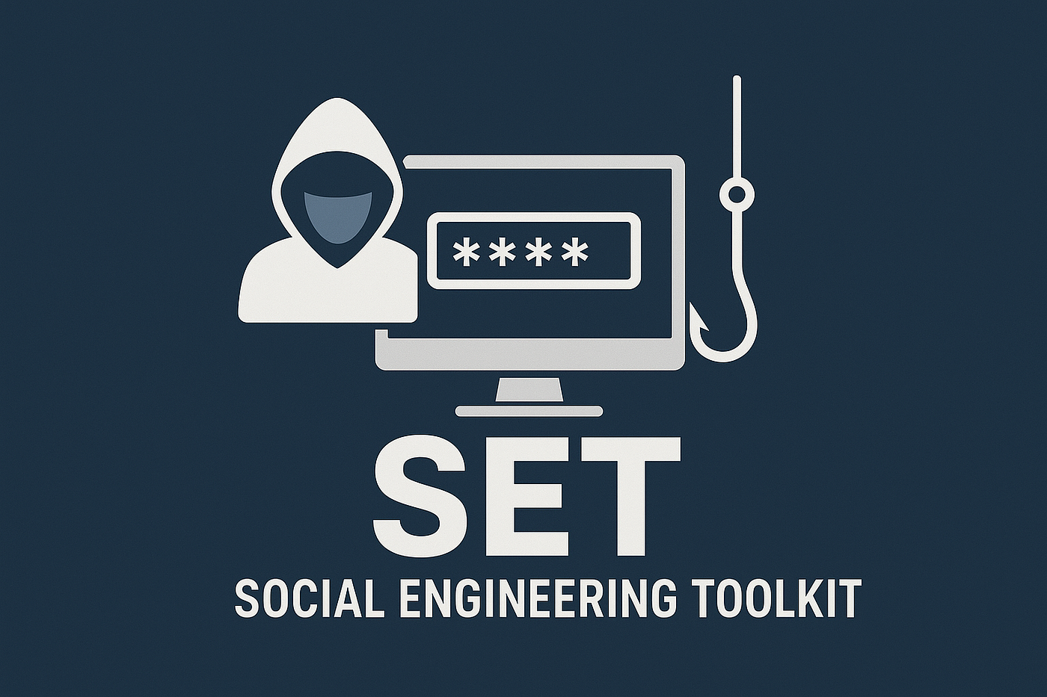
These modules integrate with email spoofing libraries and social engineering templates, making it straightforward to launch convincing, targeted campaigns against individuals or entire organisations.

3 Survey Instrument and Methodology
The survey comprises 20 items organised into four sections: email usage and exposure, phishing awareness, security behaviours, and self-assessment. The design is grounded in Protection Motivation Theory (PMT), which posits that protective behaviour is motivated by perceived threat severity, susceptibility, and response efficacy [7].
Survey Scale: 1 = Strongly Disagree, 2 = Disagree, 3 = Neutral, 4 = Agree, 5 = Strongly Agree

Section A: Email Usage and Exposure
Q1. I receive and open emails from unknown senders regularly.
Q2. I click on links or download attachments from emails without verifying the sender.
Q3. I use the same email for both personal and work/academic accounts.
Q4. I have previously received an email I later identified as a phishing attempt.
Q5. I access my email on public or shared devices/networks.

Section B: Awareness of Phishing and SET Techniques
Q6. I understand what a phishing email is and how it differs from a legitimate email.
Q7. I am aware that tools like SET can clone real websites to steal login credentials.
Q8. I know how to identify sender address spoofing in an email.
Q9. I understand that phishing emails can carry malicious attachments (PDF, DOCX, etc.).
Q10. I am aware of spear-phishing — personalised attacks targeting a specific individual.

Section C: Security Behaviours and Precautions
Q11. I verify the sender's email address before clicking any link in an email.
Q12. I hover over links to check the actual URL before clicking.
Q13. I use multi-factor authentication (MFA) on my email account.
Q14. I report suspicious emails to my IT/security team or email provider.
Q15. I have completed phishing awareness training in the past 12 months.
Q16. I use an email security filter or spam detection tool.
Q17. I keep my email client and operating system updated to patch known vulnerabilities.

Section D: Self-Assessment and Intentions
Q18. I consider myself capable of identifying a phishing email reliably.
Q19. After reading this paper, I intend to review my current email security practices.
Q20. I would recommend phishing awareness training to colleagues or peers.

4 Key Findings and Discussion
Current empirical research highlights a critical awareness–behaviour gap in email phishing susceptibility. A 2025 Proofpoint State of the Phish report found that 84% of organisations experienced at least one successful phishing attack in the prior year, with credential theft being the primary objective in 73% of cases [8]. Meanwhile, Verizon's 2025 Data Breach Investigations Report (DBIR) confirmed that the median time for a user to click a phishing link is less than 60 seconds after delivery [9].
SET-based simulations conducted in organisational security assessments reveal that credential harvesting pages are effective against up to 45% of targeted users when combined with urgent, contextually relevant lures (e.g., "Your account will be suspended") [2]. Spear-phishing — which leverages personal details gathered from social media — achieved click rates as high as 53% in controlled penetration tests [10].
Five critical defensive measures derived from current research are:
- Enable Multi-Factor Authentication (MFA): MFA blocks over 99.9% of automated credential-stuffing attacks resulting from phished passwords [11].
- Verify sender identity and hover over links: Checking the actual URL destination and full sender address before clicking dramatically reduces click-through rates.
- Deploy email security gateways: Solutions using AI-based filtering (e.g., Microsoft Defender for Office 365, Proofpoint) block the majority of phishing emails before inbox delivery.
- Conduct regular phishing simulation and training: Organisations that run quarterly simulations reduce click rates by up to 64% over 12 months [8].
- Report and respond: Prompt reporting of suspicious emails allows security teams to pull malicious messages organisation-wide and investigate compromises early.

5 Conclusion
Email phishing, amplified by accessible tools such as the Social Engineering Toolkit, remains a dominant cyber threat that exploits human psychology rather than technical vulnerabilities. Despite increased awareness, users and organisations continue to suffer significant financial and reputational harm from successful phishing campaigns. The survey instrument presented here, grounded in Protection Motivation Theory, provides researchers and educators with a structured mechanism to assess susceptibility and guide targeted training interventions.
Technical controls — including MFA, AI-driven email filtering, and endpoint protection — must be complemented by continuous human-centred education. Regular phishing simulations, clear reporting procedures, and a security-aware organisational culture are essential to close the awareness–behaviour gap. Future research should examine the effectiveness of SET-based simulations as ethical training tools in higher education cybersecurity programmes and measure longitudinal behaviour change across diverse user populations.

References
- Cisco Systems, "Cisco Annual Cybersecurity Report 2024," Cisco, San Jose, CA, USA, 2024. [Online]. Available: https://www.cisco.com
- TrustedSec, "The Social-Engineer Toolkit (SET) Repository," GitHub, 2025. [Online]. Available: https://github.com/trustedsec/social-engineer-toolkit
- K. Krombholz, H. Hobel, M. Huber, and E. Weippl, "Advanced social engineering attacks," Journal of Information Security and Applications, vol. 22, pp. 113–122, Jun. 2015.
- Statista, "Number of phishing emails sent per day worldwide 2024," Statista, Hamburg, Germany, 2025. [Online]. Available: https://www.statista.com
- IBM Security, "Cost of a Data Breach Report 2024," IBM Corp., Armonk, NY, USA, 2024. [Online]. Available: https://www.ibm.com/reports/data-breach
- Intel Security, "Phishing: Don't Take the Bait," McAfee/Intel Security, 2025. [Online]. Available: https://www.mcafee.com
- S. Sitaraman, R. Gerdes, and A. Sharma, "Blind-trust: Raising awareness of the dangers of using unsecured public Wi-Fi networks," Computer Communications, vol. 200, pp. 1–15, 2023. doi: 10.1016/j.comcom.2023.08.031
- Proofpoint, "2025 State of the Phish Report," Proofpoint Inc., Sunnyvale, CA, USA, 2025. [Online]. Available: https://www.proofpoint.com
- Verizon, "2025 Data Breach Investigations Report (DBIR)," Verizon Business, Basking Ridge, NJ, USA, 2025. [Online]. Available: https://www.verizon.com/business/resources/reports/dbir/
- F. Mouton, L. Leenen, and H. S. Venter, "Social engineering attack examples, templates and scenarios," Computers & Security, vol. 59, pp. 186–209, Jun. 2016.
- Microsoft, "Your Pa$$word doesn't matter," Microsoft Security Blog, 2019. [Online]. Available: https://techcommunity.microsoft.com/t5/microsoft-entra-blog

